Floor Plans

The Penthouse Floor has 12 units with 1 or 2 bedrooms. The square footages range from 1,122' living space/210' balcony to 2,383' living space/784' balcony. Floor plans for these units are available from the management office.

Floors 2-17 have 14 units per floor with a center corridor. The following plans are the original standard floor plans for the west side units 01-07. Units 08-14 are mirrored on the east side. Over the years some units have undergone approved renovations that have altered the layout of these units slightly.

Units are numbered with the floor number first then the unit numbers.
Example: Unit 1008 is on the 10 floor and is floor plan for unit 8.

Unit 01 - mirror unit 08
Square Footage 1095 - Balcony 154 sq. ft.
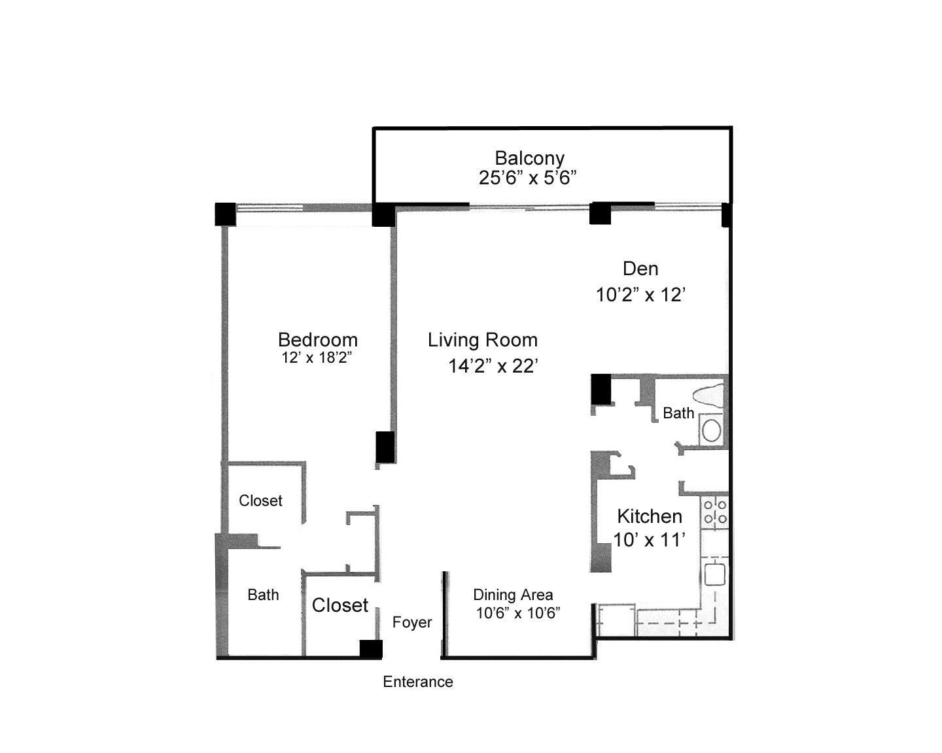
Unit 02 - mirror unit 09
Square Footage 1456 - Balcony 170 sq. ft.
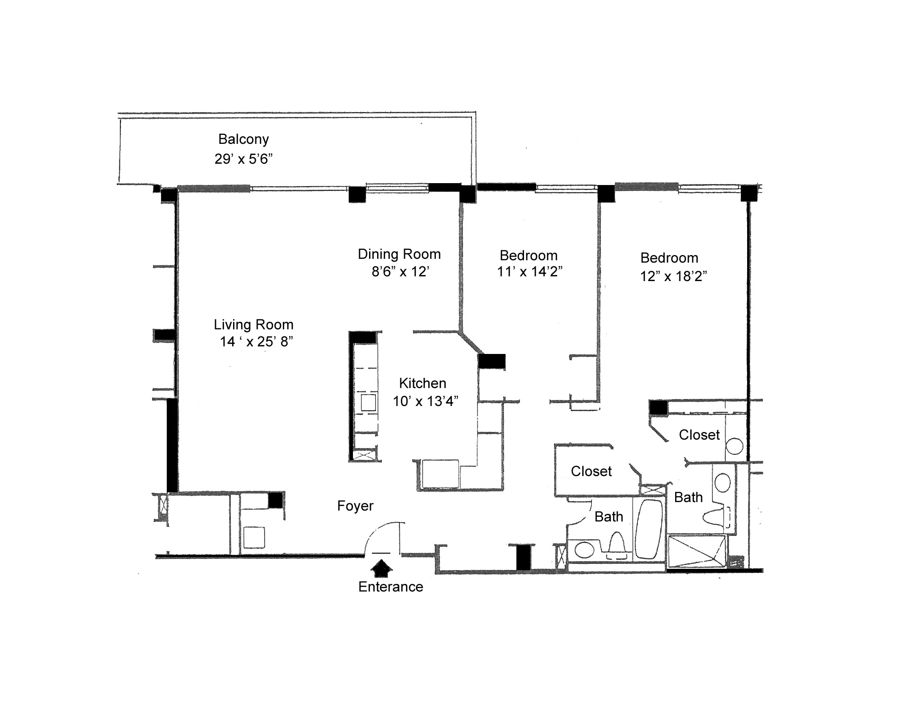
Page 1 of 4

Unit 03 - mirror unit 010
Square Footage 1095 - Balcony 154 sq. ft.
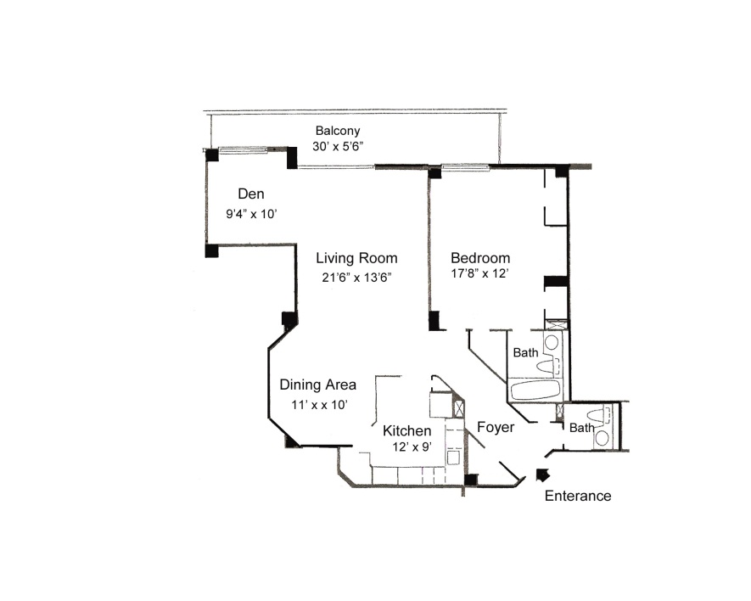

Unit 04 - mirror unit 011
Square Footage 1606 - Balcony 239 sq. ft.
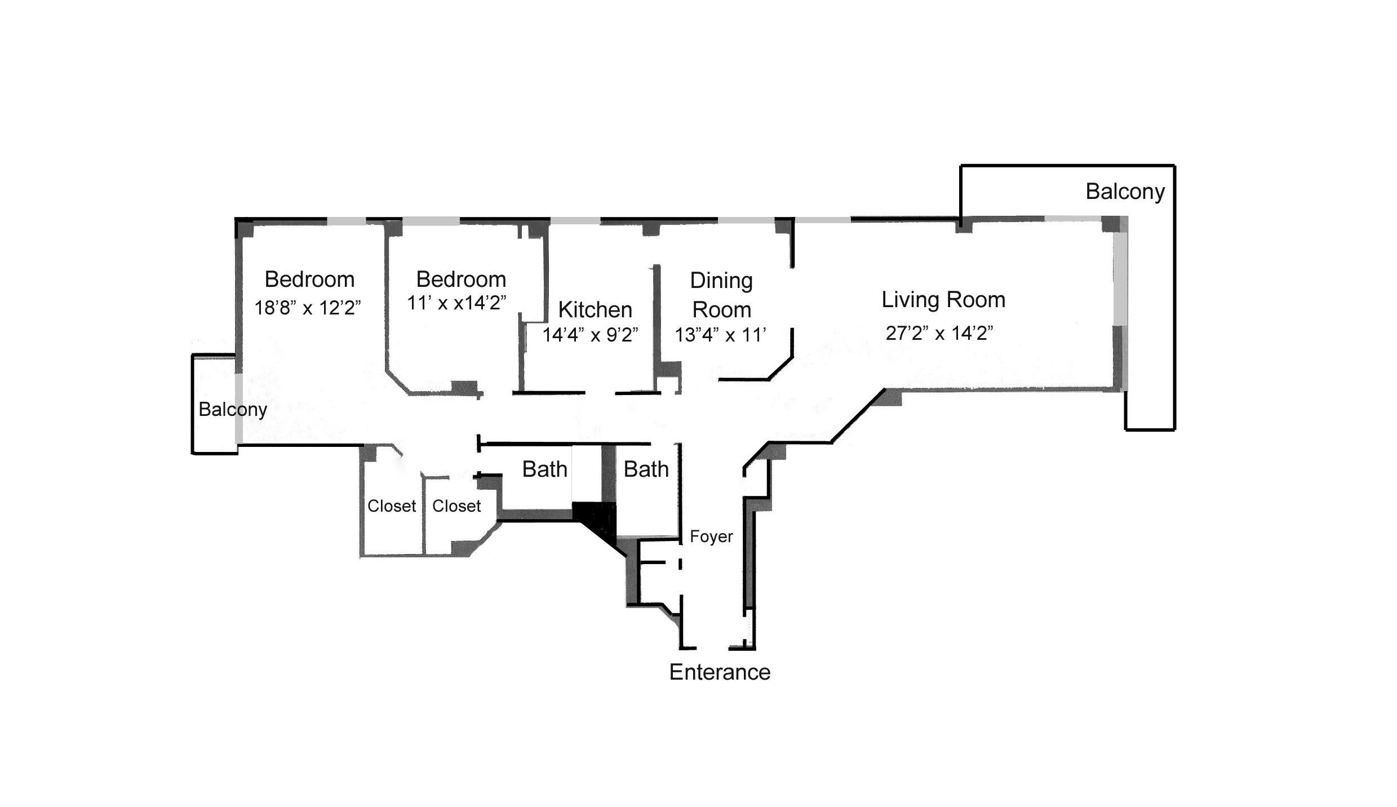

Page 2 of 4

Unit 05 - mirror unit 012
Square Footage 992 - Balcony 166 sq. ft.
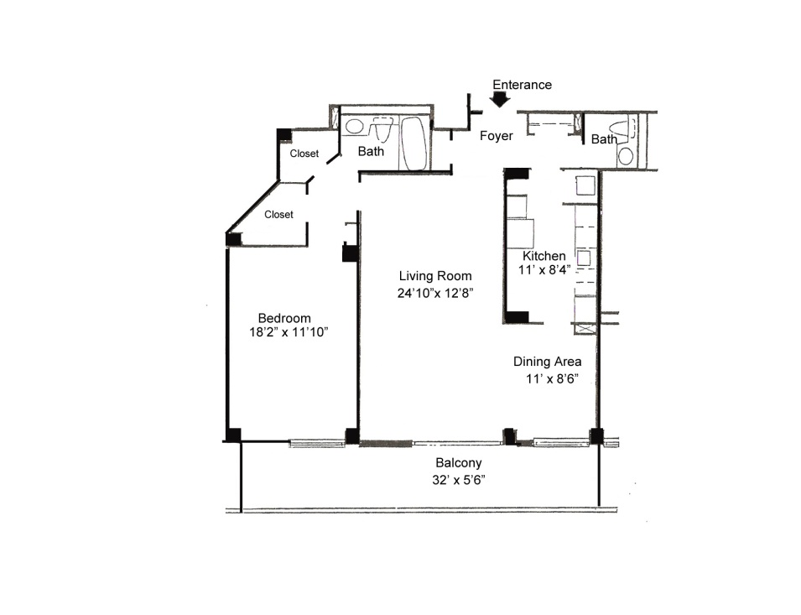

Unit 06 - mirror unit 013
Square Footage 1345 - Balcony 135 sq. ft.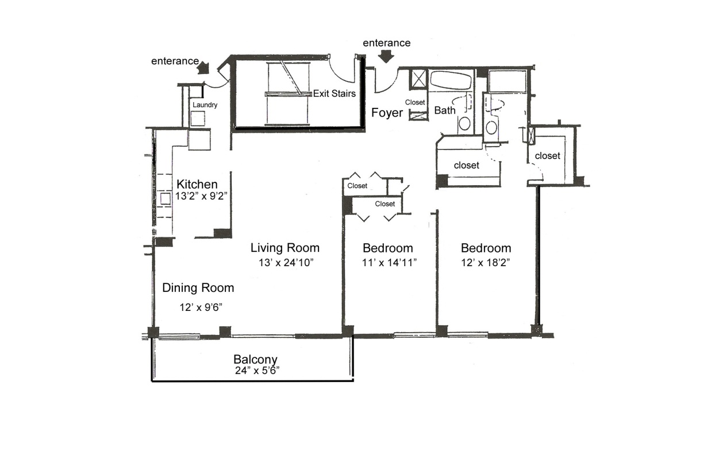

Page 3 of 4

Units 07 - mirror unit 014
Square Footage 1285 - Balcony 120 sq. ft.
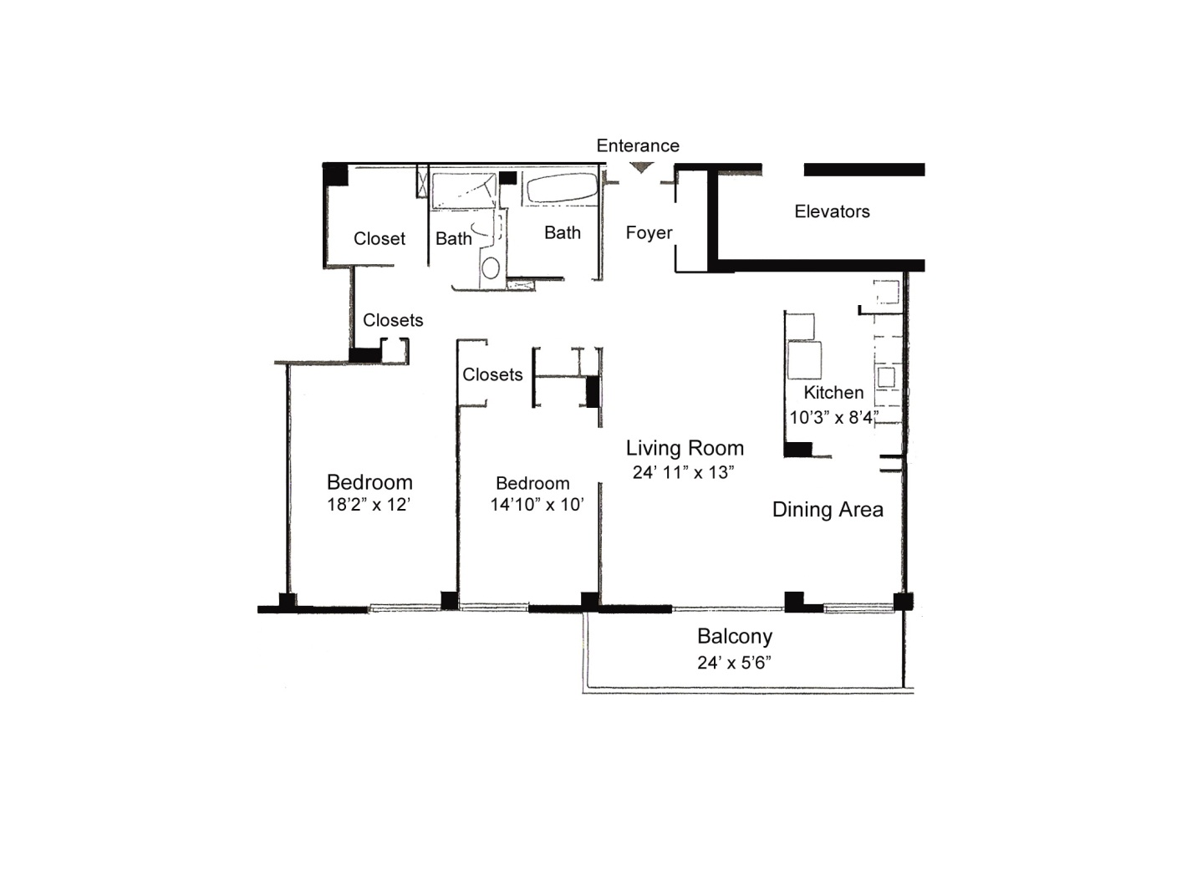

Page 4 of 4

